# Exercise: Adding a measure

## **Introduction**

You have gained a good understanding of measures and how to create them using DAX and using the quick measure feature of Power BI.

In this exercise, you must apply your knowledge of measures by writing DAX expressions in Power BI for Adventure Works. You go through each step of creating a new measure calculation within your data model to enhance the reporting visualization and answer specific business questions.

By completing this exercise, you will demonstrate your ability to:

* Create a quick measure from the existing dataset within your data model.
* Create a measure by writing DAX expression.
* Format the measures for an appropriate data type.

## **Scenario**

Adventure Works needs your help calculating its sales data using quick measures and DAX. Its main objective is to compute the running total for sales of its product line. This accumulated data will help the company analyze its sales trend based on various factors, like time, categories, salespersons, and resellers. It can then use these insights to make informed decisions.

Adventure Works provides a Power BI project file called *AdventureWorks.pbix*. that contains the required data model. You must load this dataset into Power BI, evaluate the data quality, and configure the model to ensure that Adventure Works can use it to make informed decisions.

[Adventure Works - Adding a measure exercise](https://d3c33hcgiwev3.cloudfront.net/q3zRVekuT2W28bgIb8uvOA_d0ef7f598022402683ea0d5ef82b93a1_Adventure-Works---Adding-a-measure-exercise.pbix?Expires=1751068800&Signature=HGSqmS6V8wKahhVc~uM2qyGNbR7ExtzPYy9xfwtsc5BXuJ1lOKPgRBcASrD5GyRgBHhoT~x7cy76X7WEIkv0RPNTJny2cZ0q6AVs2HmFCarefHLy5dgUQyfV85h8iMNDHJPADmPhs0hmyRaNLEgC3bgJg7SuvJPLj3aDuTylibM_&Key-Pair-Id=APKAJLTNE6QMUY6HBC5A)

[PBIX File](https://d3c33hcgiwev3.cloudfront.net/q3zRVekuT2W28bgIb8uvOA_d0ef7f598022402683ea0d5ef82b93a1_Adventure-Works---Adding-a-measure-exercise.pbix?Expires=1751068800&Signature=HGSqmS6V8wKahhVc~uM2qyGNbR7ExtzPYy9xfwtsc5BXuJ1lOKPgRBcASrD5GyRgBHhoT~x7cy76X7WEIkv0RPNTJny2cZ0q6AVs2HmFCarefHLy5dgUQyfV85h8iMNDHJPADmPhs0hmyRaNLEgC3bgJg7SuvJPLj3aDuTylibM_&Key-Pair-Id=APKAJLTNE6QMUY6HBC5A)

## **Instructions**

Create a new Power BI project called *Exercise – Adding a measure*. Follow the steps below to complete the exercise.

### **Step 1: Download the Adventure Works Power BI project.**

1. Download and save the Power BI project file Adventure Works.pbix. The file comprises a data model containing five data tables: Salesperson, Region, Date, Products and Sales.

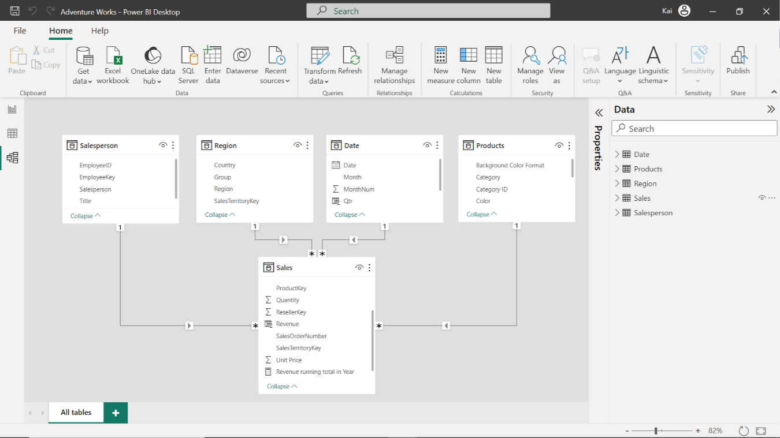

### **Step 2: Create a Quick Measure.**

1. Once the data is loaded into the data model, create a new quick measure called Running Total in Year to calculate the running total of Adventure Work’s sales. You must create this measure using the Total Sales column from the Sales table and the Year column from the Date table.
2. Format the measure as currency data type within two decimal places.

Tip: You can create this measure by using Power BI’s Quick Measure feature.

### **Step 3: Create a measure using a DAX query.**

1. Create an additional measure in the Sales table called Total Revenue using a DAX query. The measure must calculateAdventure Work’s total revenue by multiplying the Quantity of each product by its respective Unit Price.
2. Format the measure as currency data type within two decimal places.

Tip: You can create this measure using the SUMX DAX function in the formula bar of Power BI’s desktop interface.

### **Step 4: Save the Power BI project.**

Save your Power BI project to your local computer.

Tip: Make sure you select an appropriate project name and folder path.

## **Conclusion**

With these steps, you have successfully created two measures, one using the quick measure feature and the second by writing a DAX query. These measures will help you analyze Adventure Works data based on the analytical and business requirements.

Remember that when using DAX formulas, always ensure they are correctly formatted and that the column names match the actual column names in your data.